**Write a shell script to create file named student with fields (Rollno, Student name, marks) fields are separated by colon (:) write a shell script to perform the following options on this file:-**

**1) Display the contents of the file**

**2) Rename the file**

**3) Extract name if marks are greater than 75.**

**4) Sort the file based on name**

**(Hint: Use Case Structure)**

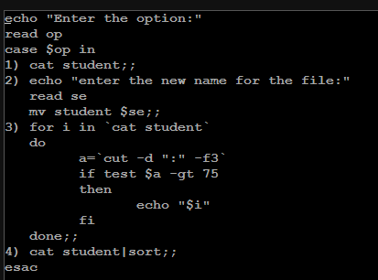

**Write a shell program to check for at least ten characters in a string and if a string has a zero length then discard it before counting the characters.**

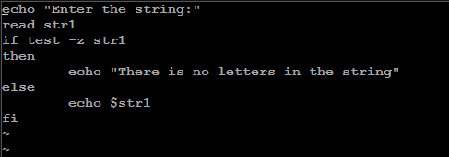

**Input a file & input number of lines in a file (let N number of lines are inserted), display the first M lines from the file. In case, M exceeds the total number of lines i.e. N then display the suitable error message.**

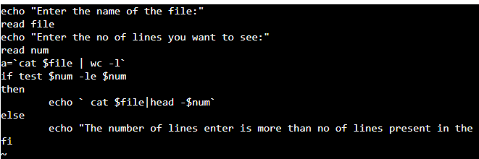

**Write a shell program to check whether the number of files created in the MORNING or AFTERNOON or EVENING from the current working directory.(for Loop)**

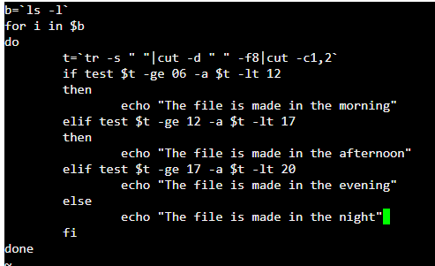

**Write a shell script to accept a directory from the user exists convert all the files from set directory into capital letters if they are 10 char longs.**

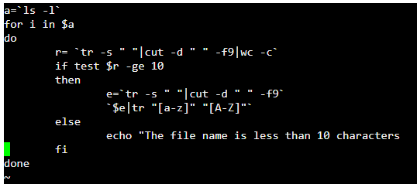

**Write a shell script for a student file with the following fields rollno, name & marks. Generate two files, ‘pass’ & ‘fail’ containing records of students who have passed or failed.**

